|  |  |
| --- | --- |
| 翻译前字数 | 2646 |
| 目录 | * Unity User Manaual(5.6)/2D/Physics Reference 2D/ Physics 2D Settings |
| 链接 | https://docs.unity3d.com/Manual/class-Physics2DManager.html |

**Physics 2D Settings**

**2D物理设置**

The **Physics 2D Settings** allow you to provide global settings for 2D physics (menu: **Edit** > **Project Settings** > **Physics 2D**).

2D物理设置为您提供了为2D物理的全局设置（菜单：Edit > Project Setting > Physics 2D).

(There is also a corresponding [Physics Manager](https://docs.unity3d.com/Manual/class-PhysicsManager.html) for 3D projects.)

（也是对应3D项目的物理管理器）

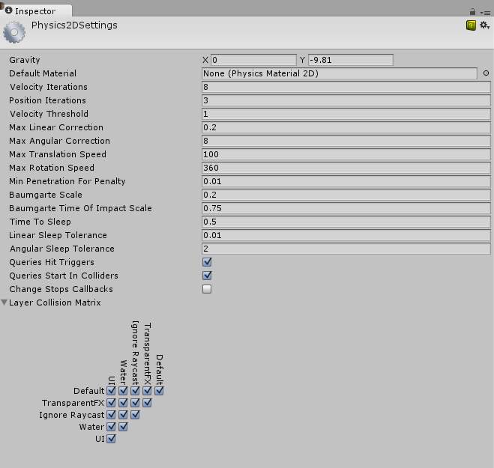

**Properties**

| ***Property:*** | ***Function:*** |
| --- | --- |
| **Gravity** | The amount of gravity applied to all [Rigidbody 2D](https://docs.unity3d.com/Manual/class-Rigidbody2D.html) GameObjects. Generally, gravity is only set for the negative direction of the y-axis.  应用到所有2D缸体的游戏对象的重力。通常，重力仅设置为Y轴的负方向。 |
| **Default Material** | The default [Physics Material 2D](https://docs.unity3d.com/Manual/class-PhysicsMaterial2D.html) that is used if none has been assigned to an individual Collider 2D.  默认的2D物理材质是用于没有指定2D的碰撞器 |
| **Velocity Iterations** | The number of iterations made by the physics engine to resolve velocity effects. Higher numbers result in more accurate physics but at the cost of CPU time.  物理引擎用于解决速度影响的迭代次数。其值越高物理会越精确，但会消耗更多的CPU处理时间。 |
| **Position Iterations** | The number of iterations made by the physics engine to resolve position changes. Higher numbers result in more accurate physics but at the cost of CPU time.  由物理引擎解决改变位置时的迭代次数。值越高物理越精确，但也会消耗更多的CPU处理时间。 |
| **Velocity Threshold** | Collisions with a relative velocity lower than this value is treated as inelastic collisions (that is, the colliding GameObjects do not bounce off each other).  相对速度低于该值的碰撞被视为弹性碰撞（即碰撞的游戏对象不会相互反弹） |
| **Max Linear Correction** | The maximum linear position correction used when solving constraints (from a range between 0.0001 to 1000000). This helps to prevent overshoot. |
| **Max Angular Correction** | The maximum angular correction used when solving constraints (froma range between 0.0001 to 1000000). This helps to prevent overshoot.  当求解约束时的最大线性位置纠正（0.0001到1000000之间的范围）。这有助于防止过冲。 |
| **Max Translation Speed** | The maximum linear speed of a Rigidbody 2D GameObject during any physics update.  在有2D缸体的游戏对象物理更新时的最大线性速度 |
| **Max Rotation Speed** | The maximum linear speed of a Rigidbody 2D GameObject during any physics update.  在有2D缸体的游戏对象的物理更新时的最大线性速度。 |
| **Min Penetration For Penalty** | The minimum contact penetration radius allowed before any separation impulse force is applied.  在应用任意单独的冲击力之前所允许的最小接触穿透半径。 |
| **Baumgarte Scale** | Scale factor that determines how fast collision overlaps are resolved.  受时间影响的重叠问题解决速度的比例因子。 |
| **Baumgarte Time of Impact Scale** | Scale factor that determines how fast time-of-impact overlaps are resolved.  受时间影响的重叠问题解决速度的比例因子。 |
| **Time to Sleep** | The time (in seconds) that must pass after a Rigidbody 2D stops moving before it goes to sleep.  当2D缸体停止移动进入休眠之前所需要的时间（秒）。 |
| **Linear Sleep Tolerance** | The linear speed below which a Rigidbody 2D goes to sleep after the **Time to Sleep** elapses.  2D缸体在休眠时间过去后进入休眠状态的线性速度。 |
| **Angular Sleep Tolerance** | The rotational speed below which a Rigidbody 2D goes to sleep after **Time to Sleep** elapses.  2D缸体在休眠时间过去后进入休眠状态的旋转速度。 |
| **Queries Hit Triggers** | Check this box to enable Collider 2Ds marked as **Triggers** to return a hit when any physics queries (such as Linecasts or Raycasts) intersect with them. Leave it unchecked for these queries to not return a hit.  勾选此选项将2D碰撞体设为触发器，当任何物理物理查询（如Linecasts或者Raycasts）与之相交时返回，取消选中将不会返回命中。 |
| **Queries Start In Colliders** | Check this box to enable physics queries that start inside a Collider 2D to detect the collider they start in.  勾选此框开启碰撞检测机内部对的物理查询 |
| **Change Stops Callbacks** | Check this box to stop reporting collision callbacks immediately if any of the GameObjects involved in the collision are deleted or moved.  任意游戏物体在碰撞时删除或者移动时，勾选此选项会立刻停止报告的碰撞回调 |
| **Layer Collision Matrix** | Defines how the [Layer-based collision](https://docs.unity3d.com/Manual/LayerBasedCollision.html) detection system behaves.  定义了基于层的碰撞是如何发现系统行为的方式 |

**Notes**

The Physics 2D Settings define limits on the accuracy of the physical simulation. Generally speaking, a more accurate simulation requires more processing overhead, so these settings offer a way to trade off accuracy against performance. See the [Physics](https://docs.unity3d.com/Manual/PhysicsSection.html) section of the manual for further information.

2D物理设置定义物理模拟的准确性限制。一般来说，更准确的模拟要求更多的处理消耗，所以这些设置提供了一种权衡准确性和性能的方式。参见手册的物理章节获取更多的信息。